Project ‚RIS2BI‘

(BOARD Release 1.1)

Specification

Author :

Date : 20.12.2015

Status : updated by LQV

Content list

1.1 Project goals 3

1.2 Project scope and business Intelligence (BI) system landscape 3

1.3 Project organisation 4

2.1 Portal Layout and Navigation 5

3.1 Currency 5

4.1 IT infrastructure 6

4.2 BOARD folder structure 7

4.3 Data Warehouse (SQL Server) 8

4.3.1 Nomenclature for database tables / views 8

4.3.2 Source tables of RIS 8

4.4 Multidimensional Database (BOARD) 9

4.4.1 No. of Cases 9

4.4.2 Mandays 9

4.4.3 No. of Offers / Value /DB2 per expected decision Date 10

4.4.4 No. of Offers / Value /DB2 per Offer Date 10

4.4.5 No. of Projects 11

4.4.6 No. of Sales Activities 11

4.5 Mapping BOARD to RIS Tables 12

4.6 Technical Integration – ETL Process 14

4.7 Technical Integration – Views 14

4.8 Technical Integration – BOARD 16

4.9 Ranking and scoring: 17

4.9.1 Introduction 17

4.9.2 Cubes 17

4.9.3 Data warehouse and ETL process 19

5.1 User license profiles of BOARD - an overview 20

5.2 Authorization Concepts within capsules and databases 21

5.3 How to create and maintain user profiles 21

5.4 Current Authorization Matrix 21

1. Introduction

Project goals

The project goals for “RIS2BI” are

* Introduction of an Reporting across Sales Key Performance Indicators (KPI`s), based on the SugarCRM database
* Efficient and user-friendly provision of the new Sales KPI´s in the BOARD Reporting Portal for BU-/ Industry Management and Coordination Board
* Standardisation and establishment of Sales KPI definition across the Rieckermann Group

Project scope and business Intelligence (BI) system landscape

The project scope is defined in the attached project plan. The figure below shows the scope and building blocks of the new Rieckermann Business Intelligence Solution. One new System will be attached: The CRM Application “Sugar CRM” (RIS).



Figure 1: Scheduled Business Intelligence System landscape

The relational database (MS SQL) will be connected with ETL processes with RIS.

In BOARD three different building blocks will be implemented: multidimensional Database and Cubes, Reporting Portal, Planning workflow and data entry masks.

Any connections to other Rieckermann systems and databases are out of scope of the current project module until Jan. 31th 2014.

Project organisation

The below shown project organisation delivers the new reporting and budgeting solution until January 2014. The sub-project teams are staffed with internal and external experts to ensure a successful project.

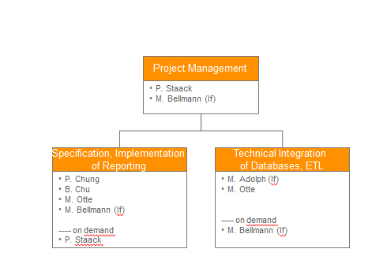

Figure 2: Project organisation

1. Module 1: Reporting Design

Portal Layout and Navigation

There are four different portal layouts: CB, IM, BU and FCC.

1. Module 2: Corporate Standards and processes

Currency

All the currency coversion (from local currencies to EURO) will be conducted in the CRM Application “Sugar CRM” (RIS). No currency coversion will be taken out in this BI tool.

1. Module 3: Overview Technical Integration of BOARD, MS SQL

IT infrastructure

The source data for the reporting portal is located in an MySQL-Database (10.99.2.11)

All relevant data will be collected in one relational database, the „Data Warehouse“ (DWH). In the DWH the data will be transformed and conditioned for reporting and analysis, e.g.:

1. adaption of data (e.g. different charts of accounts)
2. identification and cleansing of false data

The DWH is running on a Windows server und a SQL Server 2008 R2. For building, operating und monitoring of the data flows, Microsofts SQL Server Integration Services (SSIS) is used.

BOARD folder structure

The BOARD folder is located in “D:\BOARD” on the BOARD server. The capsule folder has the following structure:



The “live” capsule is located in the main capsule folder and the current development capsule in the folder “development”. When the current development is finished and tested successfully, the capsule will be copied to the main capsule folder.

Data Warehouse (SQL Server)

Nomenclature for database tables / views

The following table shows the nomenclature for the database table and views in the Data Warehouse. The intention of the nomenclature is that the name of the tables describes the origin and the function of the table/view:

|  |  |  |
| --- | --- | --- |
| **Type** | **Nomenclature** | **Example** |
| complete table of pre-system | LZ_<shortname source system>_<name of table in source system> | LZ_RIS_accounts (customers) |
| intermediate temporary data | TMP_ |  |
| view | V_ |  |
| historical data | HIST_<figure> | HIST_OrderIntake |
| target table fact data | FAKT_<figure> | FAKT_Turnover |
| target table dimensional data | DIM_<dimension> | DIM_BusinessUnit |

Source tables of RIS



**j**

**r_offers**



**jr_saleproject**



**jr_salesctivity**



**cases**

**E**

**xplanation**

**Databasemodel**

**users**

**a**

**ccounts_jr_saleproject_c**

**jr_main_industry**

**a**

**ccounts**

**jr_makers**

**a**

**ccounts_jrsaleactivity_c**

**a**

**ccounts_jr_offer_c**

**accounts_cases**

**a**

**ccounts_cstm**



n

1

1

1



**Cases_cstm**

Multidimensional Database (BOARD)

For building the needed Reports, the following Cubes will be provided in BOARD:

No. of Cases

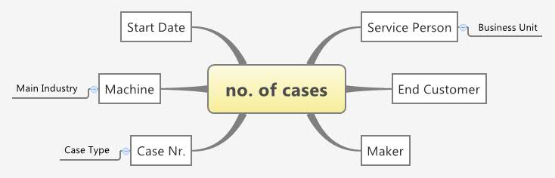

Mandays

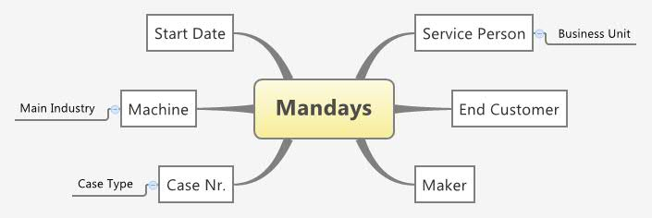

No. of Offers / Value /DB2 per expected decision Date

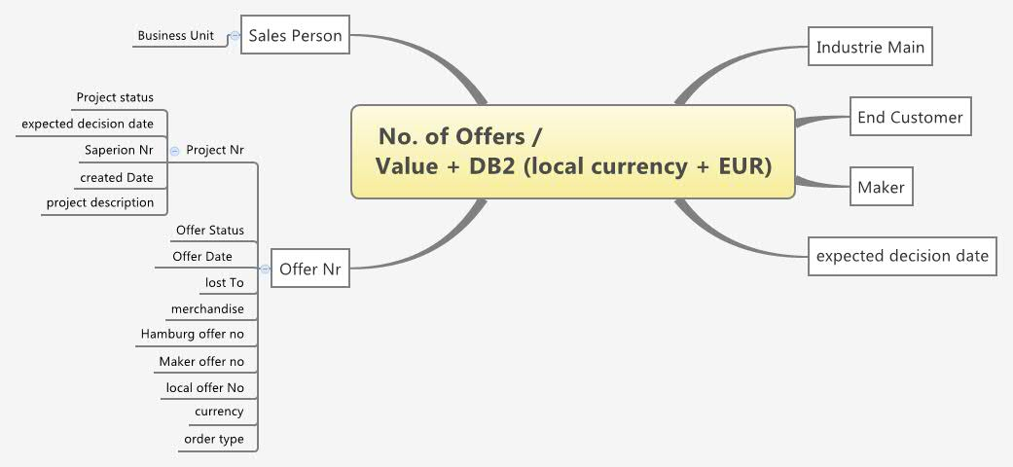

### No. of Offers / Value /DB2 per Offer Date

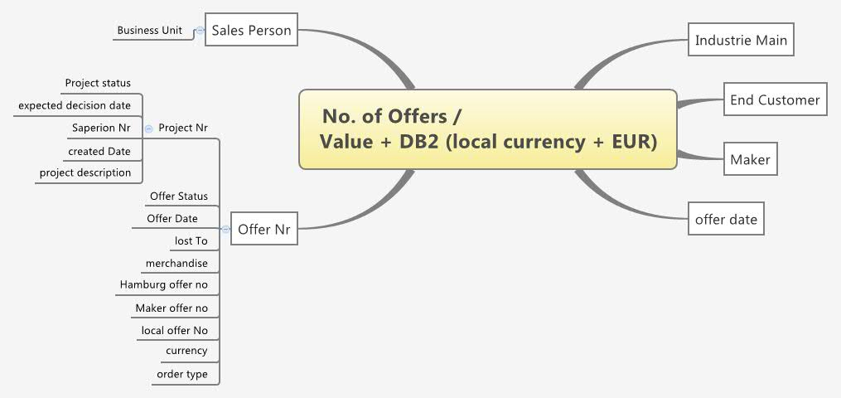

No. of Projects

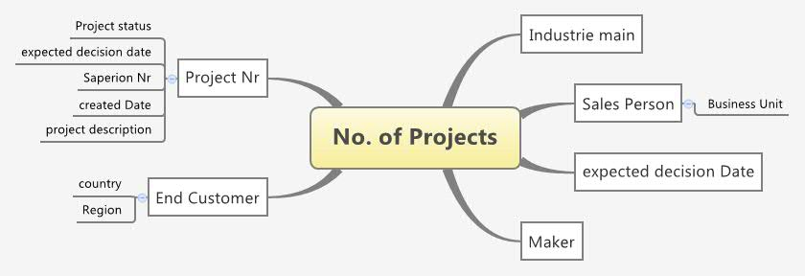

No. of Sales Activities

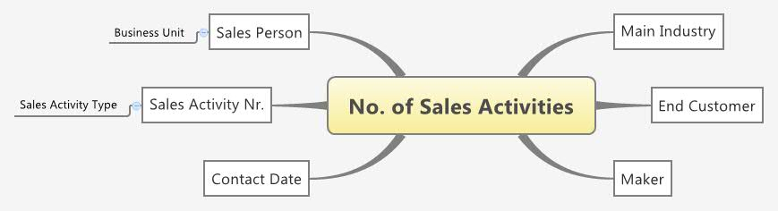

Mapping BOARD to RIS Tables

The following table shows the mapping between the objects in BOARD and the Source Tables in RIS:

|  |  |  |  |
| --- | --- | --- | --- |
| **BOARD Object** | **Type** | **Source Table** | **Source Field** |
| Sales Person | Entity code | users | user_name |
|  | Entity desc | users | first_name + ' ' + last_name |
| Business Unit | Entity code | users | opt_business_unit |
| User Function | Entity code | users | Jr_function |
| End Customer | Entity code | accounts | id |
|  | Entity desc | accounts | name |
| Customer Country | Entity code | accounts_cstm | opt_country_c |
| Customer Region | Entity code | accounts_cstm | opt_region_c |
| Maker | Entity code | makers | id |
|  | Entity desc | makers | name |
| Industry sub | Entity code | jr_industry | id |
|  | Entity desc | jr_industry | name |
| Industry main | Entity code | jr_main_industry | main_industry_code |
|  | Entity desc | jr_main_industry | name |
| merchandise | Entity code | jr_offer | opt_offer_merchandise |
| Hamburg offer no | Entity code | jr_offer | txt_hamburg_no |
| Maker offer no | Entity code | jr_offer | txt_maker_offer_no |
| Lost to | Entity code | jr_offer | lost_to |
| local offer no | Entity code | jr_offer | name |
| Offer status | Entity code | jr_offer | opt_offer_status |
| offer Date | Entity code | jr_offer | date_offer |
| Offer | Entity code | jr_offer | id |
|  | Entity desc | jr_offer | name |
| Order Type | Entity code | jr_offer | opt_order_type |
| Project | Entity code | jr_saleproject | jr_saleproject_number |
|  | Entity desc | jr_saleproject | name |
| Project status | Entity code | jr_saleproject | opt_project_outcome |
| expected decision date | Entity code | jr_saleproject | date_expected_decision |
| Saperion Nr | Entity code | jr_saleproject | txt_superion_project_no |
| Project created Date | Entity code | jr_saleproject | date_entered |
| Project description | Entity code | jr_saleproject | description |
| Case | Entity code | cases | case_number |
|  | Entity desc | cases | name |
| Case Type | Entity code | cases | type |
| Machine | Entity code | cases_cstm | txt_machine_c |
| Case Start Date | Entity code | cases_cstm | date_open_c |
| Sales Activity | Entity code | jr_saleactivity | id |
|  | Entity desc | jr_saleactivity | name |
| Sales Activity Type | Entity code | jr_saleactivity | opt_type_contact |
| Contact Date | Entity code | jr_saleactivity | date_contact |
| Offer Value | cube value | jr_offer | amount |
| Offer DB2 | cube value | jr_offer | eur_db2_amount |
| Currency | Entity_code | jr_offer | jr_currencies_id_c |
| Offer value EUR |  |  |  |
| Offer DB2 EUR |  |  |  |
|  |  |  |  |
|  |  |  |  |
|  |  |  |  |
|  |  |  |  |
|  |  |  |  |
|  |  |  |  |
|  |  |  |  |
|  |  |  |  |
|  |  |  |  |
|  |  |  |  |
|  |  |  |  |
|  |  |  |  |
|  |  |  |  |
|  |  |  |  |
|  |  |  |  |
|  |  |  |  |
|  |  |  |  |
|  |  |  |  |
|  |  |  |  |
|  |  |  |  |
|  |  |  |  |
|  |  |  |  |
|  |  |  |  |
|  |  |  |  |
|  |  |  |  |
|  |  |  |  |
|  |  |  |  |
|  |  |  |  |
|  |  |  |  |
|  |  |  |  |
|  |  |  |  |
|  |  |  |  |
|  |  |  |  |
|  |  |  |  |
|  |  |  |  |
|  |  |  |  |
|  |  |  |  |
|  |  |  |  |
|  |  |  |  |

## Technical Integration – ETL Process

This part of the specification explain, how the RIS data is load to the DWH. In the first step we load all relevant RIS tables as a 1:1 copies in our DWH (SQL Server 2008). The name of the database is “Staging”. To get the copys of the tables we use the SQL Server Integration Services Tool (SSIS). With this tool you can create packages to Extract, Transform and Load data from your source System to your destination system.

The file that contains the ETL Process for our RIS tables is stored on the BI Server under “D:\SSIS\RIS” and has the name “RIS.sln”. You can open the file per double-click on it.

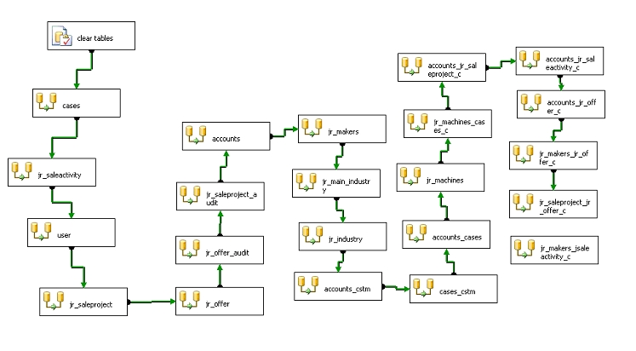

In this SSIS package all relevant RIS tables are load to our Data Warehouse.

## Technical Integration – Views

To load the data from the DWH to Board we create Views. In this Views we join all relevant tables for our four figures.

So we have the following views:

* vFACT_RIS_Cases
* vFACT_RIS_Offer
* vFACT_RIS_SalesActivity
* vFACT_RIS_SalesProject.

For the Number of Cases we need the following tables:

* LZ_RIS_cases
* LZ_RIS_cases_cstm
* LZ_RIS_accounts_cases

For the Number of Sales Activities we need the following tables:

* LZ_RIS_jr_saleactivity
* LZ_RIS_jr_accounts_jrsaleactivity_c
* LZ_RIS_jr_makers_jsaleactivity_c

For the Number of Offers and Offer Values we need the following tables:

* LZ_RIS_jr_offer
* LZ_RIS_accounts_jr_offer_c
* LZ_RIS_makers_jr_offer_c
* LZ_RIS_jr_saleproject_jr_offer_c

For the Number of SalesProjects we need the following tables:

* LZ_RIS_jr_saleproject
* LZ_RIS_jr_accounts_jr_salesproject_c

For all Views we join the following tables to get further informations:

* LZ_RIS_users
* LZ_RIS_accounts
* LZ_RIS_accounts_cstm
* LZ_RIS_jr_industry
* LZ_RIS_jr_machines
* LZ_RIS_jr_main_industry
* LZ_RIS_jr_makers

The Number of Cases are filtered as followed: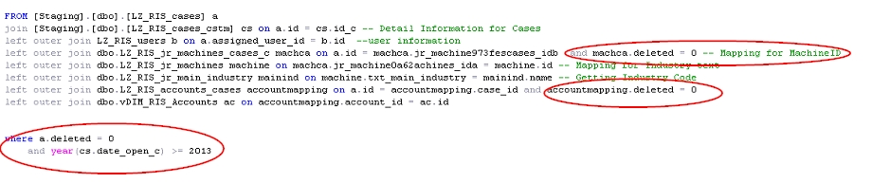

All Cases that are not deleted and where the Start Date (in RIS open Date) is greater than 2012. Also we filter all machine id´s and account id´s that are not marked as deleted.

The Number of Activitys are filtered as followed:

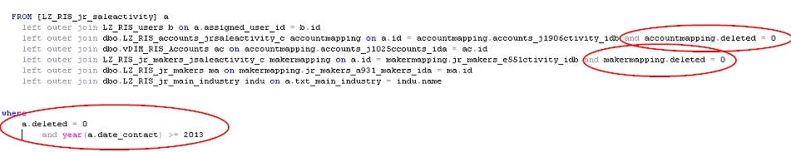

All Activitys that are not deleted and where the Contact Date is greater than 2012. Also all account id´s and maker id´s that are not marked as deleted.

The Number of Offers and Offer Values are filterd as followed:

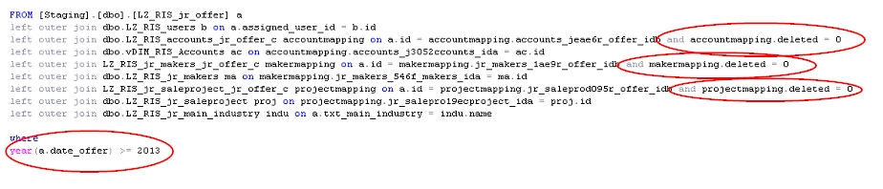

All Offers where the Offer Date is greater than 2012. Also all account id´s, maker id´s and project id´s that are not marked as deleted.

The Number of Projects are filterd as followed:

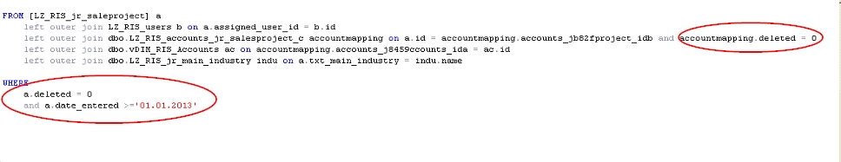

All Projects that are not deleted and where the Created Date (in RIS Entered Date) is greater than 2012. Also all account id´s that are not marked as deleted.

## Technical Integration – BOARD

From the Views we finaly load the date into the Board database “Rieckermann RIS”.

To load the data into BOARD we use the BOARD DATA READER. All information from the Views are uploaded 1:1 in Board.

In the following picture you see an example for the Data Reader in Board. In this we load all information into the entities and Cubes:

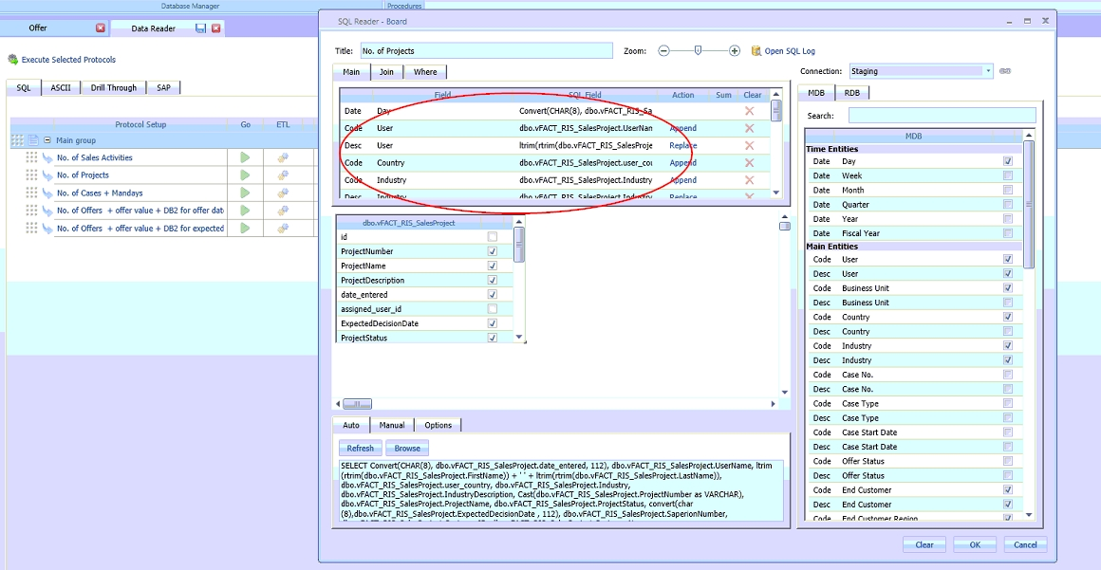

## Sales KPIs (Ranking and scoring):

Introduction

Users need to have ranking and scoring information of sales person, therefore additional cubes are developed to provide an insight into sales person information: customer base, offer, project id and closing.

Cubes

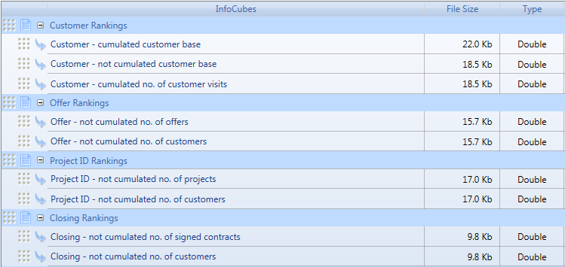

New cubes are divided into four respective groups: customer rankings, offer rankings, project ID rankings and closing rankings.

All Sales – KPIs cubes share the same structure, comprising of two entities - Quarter and User.

* Customer – cumulated customer base

The cube contains list of sales person and respective number of customers who sales person contact per quarter, the number is cumulated.

* Customer – not cumulated customer base

The cube contains list of sales person and respective number of customers who sales person contact per quarter, the number is yearly cumulated.

* Customer – cumulated no. of customer visits

The cube contains list of sales person and respective number of visits that sales person contact customer per quarter, the number is yearly cumulated.

* Offer – not cumulated no. of offers

The cube stores list of sales person and respective number of offers of which sales person are in charge per quarter, the number is yearly cumulated.

* Offer – not cumulated no. of customers

The cube stores list of sales person and respective number of customers whom sales person proposed offer per quarter, the number is yearly cumulated.

* Project ID – not cumulated no. of projects

The cube stores list of sales person and respective number of projects in which sales person get involved with per quarter, the number is yearly cumulated.

* Project ID – not cumulated no. of customers

The cube stores list of sales person and respective number of customers who sales person share the same project with per quarter, the number is yearly cumulated.

* Closing – not cumulated no. of signed contracts

The cube stores list of sales person and respective number of signed offers of which sales person are in charge per quarter, the number is yearly cumulated.

* Closing – not cumulated no. of customers

The cube stores list of sales person and respective number of customers who sales person signed contract with per quarter, the number is yearly cumulated.

Data warehouse and ETL process

Additional fact tables are created in data warehouse to reflect these Sales KPIs (see the picture below).

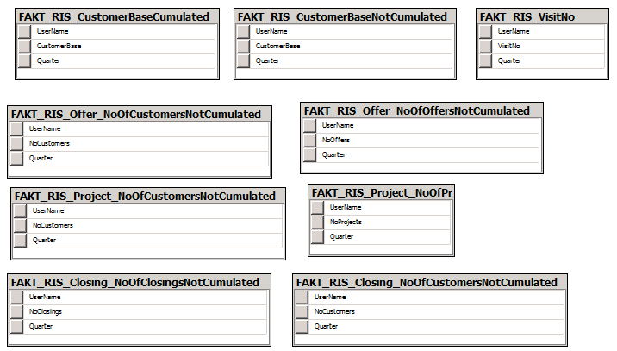

All these tables have the same structure with two common fields ( UserName - represent for Sales Person - and Quarter) and the last field indicate the figures depending on purpose of each fact table.

The ETL process to populate RIS – Sales KPIs fact tables are integrated into the SSIS package “LandingZone.dtsx”, this process is called at the end of the package, after populating RIS landing zone is finished as shown in the picture below.

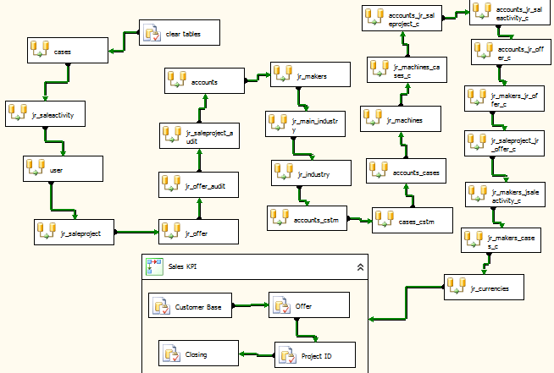

1. Authorization Concept

User license profiles of BOARD - an overview

Four different types of licenses exist, each providing a different set of functionality:

* + - Developer : this is the highest level license, it allows you to create and edit Board databases a capsules without restrictions. It is intended for Board administrators, developers and power users.
    - Power User : this license provides unrestricted access to Capsules both for navigation and for development purposes but does not allow to access any database design feature. This license is for power users that do not need to modify the design of Board databases.
    - LitePlus : this license provides access to the Capsule environment and all navigation features but does not allow to design or modify a Capsule; access to the Capsule *design* mode is prohibited. It is intended for users that only need to open existing Capsules, including budgeting and simulation applications, that have been designed for them by a user having a Developer or Power User license.
    - Lite : this license provides the same functions as the LitePlus license with the exception that data-entry is prohibited. It is essentially a ”read-only” license suitable for users that need to navigate existing Capsules with reports, charts or any other data-presentation object but who can't enter data.

Each of the above user licenses types can be upgraded with the MS-Office Add-in license which allows to use the Board Add-in for Microsoft Office 2007 or 2010.

Rieckermann owns licenses of all above named license profiles.

Authorization Concepts within capsules and databases

Three different authorization concepts are available within customer specific BOARD capsules and databases:

1. Access rights for Portal Areas (a set of reports)
2. Access rights for individual reports or data entry masks (single screens)
3. Access rights for individual database entities (e.g. business unit ‘china machinery’)

All three authorization concepts will be implemented within the Rieckermann BOARD solution. The administration of the authorization rights is only possible for BOARD users with the license type ‘Developer’. Currently (8.8.2013) Rieckermann owns one developer license. Controlling in Hamburg is responsible for the administration of the authorization concept and maintenance and obtains the ‘Developer’-License.

How to create and maintain user profiles

Chapter 5 ‘User accounts and security’ on <http://help.board.com/> describes how to create and maintain user profiles.

Current Authorization Matrix

Next to the user setting in BOARD the below illustrated authorization matrix is established to manage the authorization rights. Please see attachment 6.4 for details of the authorization matrix.



Figure 10: Authorization matrix as of August 13th 2013

Next to the above illustrated authorization matrix in Excel, the project team will implement an authorization report in BOARD to track which user obtains which rights for screens and portal areas (user in rows, screens in columns).

1. Attachments (all)